# INSTANTIATING A NEW DOMAIN

**Onboarding**

There are many options for stakeholders considering adoption of NIEM. Stakeholders may choose to contribute model content, adopt NIEM standards and protocols for creating Message Exchange Packages (MEPs – formerly, Information Exchange Package Documentation (IEPDs)), participate in NIEM exchanges, participate in the NIEM Community At-Large, join an existing domain, become an organization for the Advancement of Structured Information Standards (OASIS) NIEM Open Project member or sponsor, and/or stand up and steward a NIEM Domain.

The NIEM Business Architecture Committee (NBAC) Technical Steering Committee (TSC) can assist parties in discussing their interest, prospective level of participation and potential roles in NIEM Open Project. The distinguishing features of a domain are that it represents a unique, formal functional area Community of Interest (CoI) (i.e. Biometrics, Emergency Management, or Learning & Development as examples) under the auspices of NIEM Open Project, with an established domain governance structure, rules and processes and model content internal to that CoI/domain. Additionally, a domain acknowledges certain responsibilities to NIEM Open Project in execution of domain operations.

In general, there are several common ways by which a candidate “new” domain is identified and proposed

* + As part of NIEM Open Project operations, the need for a new, unique, domain may become transparent and NIEM Open Project/ the NBAC will explore potential candidate organizations for stewardship
  + As part of the NBAC’s normal outreach to potential “new adopters of NIEM” and organization may identify a business need that lends itself to establishing a new domain
  + An organization may approach NIEM Open Project and the NBAC and self-identify an organizational business need and interest in becoming a new NIEM domain.

Once a candidate domain and sponsoring organization(s) is identified, a sequence of administrative, technical, business, and managerial steps are tailored to support consideration for onboarding the domain (Figure -1). Many of these activities can be performed in parallel. The NBAC will provide a shepherd to assist the candidate domain throughout the process. A high-level listing of tasks includes

* + Due Diligence - (Prospective Domain)
    - Identify the organizational business need
      * Overall benefit of establishing a domain
      * Benefit to NIEM Open Project
      * Benefit to CoIs
    - Research and demonstrate a knowledge of NIEM Open Project in general
    - Research and demonstrate an understanding of the roles and responsibilities of domains
    - Participate in NIEM technical training as needed
    - Identify CoI entities/ stakeholders
    - Conduct a high-level look at the types of domain data that will be exchanged via the proposed domain
    - Identify exchange potential use cases and exchange partners
    - Assess resources required
    - Conduct cost-benefit assessment and proceed if warranted
  + Administrative - (Prospective Domain) – identify, propose
    - Domain name
    - Sponsoring organization
    - Steward
    - Support staff (management & technical)
    - Points of Contact and mailing list information
  + Administrative - (Prospective Domain) Complete the *Business Need Template* and submit to NBAC for review, validation and feedback
  + Management – (NBAC) Submit the completed *Business Need Template* to the Project Governing Board (PGB) for consideration
  + Technical - Identify initial model content (Prospective Domain)
  + Management - (Prospective Domain) - Develop Plan of Action and Milestones (POA&M) to support domain standup
  + Management - (Prospective Domain) - Develop draft domain governance document/ charter
  + Management - (Prospective Domain) Formally propose Domain to NBAC
  + **NBAC votes**, (once evaluated and documents shared) simple majority needed to recommend domain to PGB for approval
  + **PGB votes**
  + **Instantiate domain**
  + Management - (Domain) Standup domain
  + Management - (Domain) Finalize domain governance document/ charter
  + Management - (Domain) Create Standard Operating Procedures
  + Management - (Domain Steward) Appoint NBAC voting members
  + Management - (Domain) Conduct Domain Business
  + Technical - (Domain) Create MEPs and exchanges
  + Technical - (Domain) Participate in harmonization and release cycle activities
  + Management - (Domain) Conduct outreach to domain stakeholders.

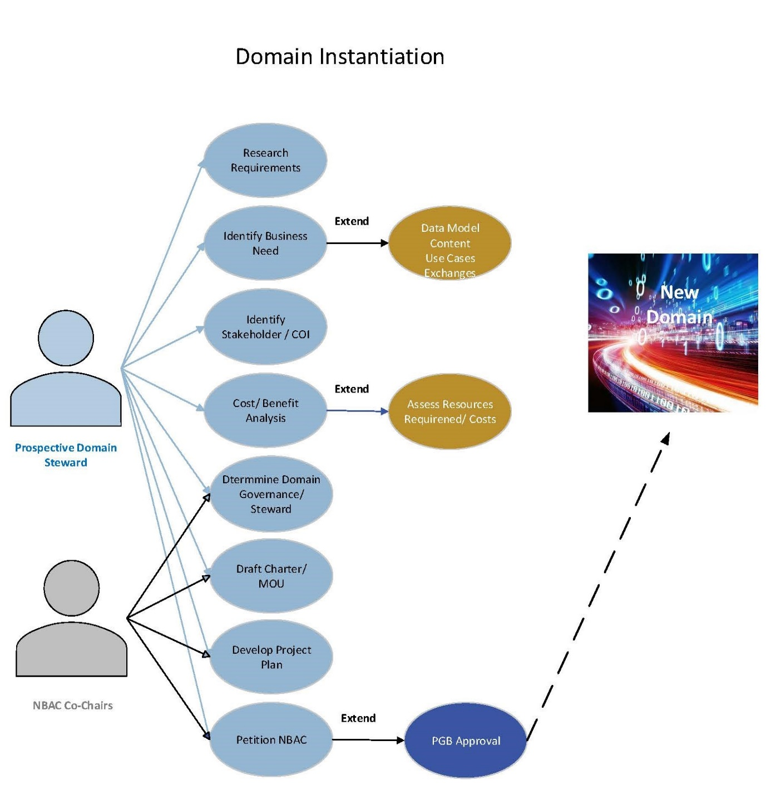

Figure Onboarding/ Instantiation Process

**Domain Conservatorship**

As domains mature, some domains reach stasis where there is no requirement to create new model content or exchanges. Additionally, there may be circumstances where a domain is suspended, terminated, or otherwise becomes dormant. If a domain is inactive, without a Steward, or dormant for a year, the NBAC may retire the domain and act as conservator for the domain’s content.